MASTER THESIS FULL TITLE

MASTER THESIS FULL TITLE

By
Your name

Advisor
Dr. /Prof.
Co-Advisor
Dr. / Prof.

Thesis submitted in partial fulfillment of the requirements for the degree of M.Sc. in

At
The Faculty of Graduate Studies
Jordan University of Science and Technology

Month, Year
THE TITLE OF THE THESIS

By
Your name

Signature of Author …………………….

Committee Members Signature and Date
Dr./ Prof.(Chairman) ……………….….
Dr. / Prof. (Co-Advisor) …….…………….
Dr. ./ Prof. (Member) ….……………….
Dr. ./ Prof. (External Examiner) ….……………….

Month, Year

تفويض

نحن الموقعين أدناه، نتعهد بمنح جامعة العلوم والتكنولوجيا الأردنية حرية التصرف في نشر محتوى الرسالة الجامعية، بحيث تعود حقوق الملكية الفكرية لرسالة الماجستير الى الجامعة وفق القوانين والأنظمة والتعليمات المتعلقة بالملكية الفكرية وبراءة الاختراع.
الطالب | المشرف الرئيس
اسم الطالب | اسم المشرف الرئيسي
الرقم الجامعي والتوقيع  ..................................  .................................. | التوقيع والتاريخ  ..................................  ..................................

DEDICATION

This Section title is optional. Perhaps you would like to dedicate your document to your parents, grandparents, or other influential figures in your life. This is the place that you would write out your dedication.

Dedicated with love to …….

ACKNOWLEDGMENT

Perhaps you wish to acknowledge your committee members or some of the fellow students that helped you work on your thesis. This may include, but is not limited to:
- Funding bodies/sponsorship providers
- Supervisors
- Professors
- Research group and lab assistants
- Research participants
- Colleagues
- Proofreaders
To help you get started, we’ve provided you with a few examples of sentences that you can complete or draw ideas from.
- I am deeply grateful to XXX…
- I would like to express my sincere gratitude to XXX…
- I would like to offer my special thanks to XXX…
- I would like to extend my sincere thanks to XXX…

TABLE OF CONTENTS

Title Page

DEDICATION I
ACKNOWLEDGMENT II
LIST OF FIGURES VI
LIST OF TABLES VII
LIST OF APPENDICES VIII
LIST OF ABBREVIATIONS IX
ABSTRACT I
Chapter One: Introduction 1
1.1 General Thesis Instructions 1
1.1.1. Fonts and Line Spacing 1
The thesis standard font is the "Times New Roman" in a double-space format with full justification (from left and right). Here note the following instructions: 1
• THE THESIS TITLE must be typed using a BOLD times new roman font with upper case (all capital letters), center-justified and 18 points font size. 1
• Use 16-points times new roman font with Upper-case font with the: DEDICATION, AKNOWLEDGEMENT, TABLE OF CONTENTS, TABLE OF FIGURES, LIST OF TABLES, LIST OF ABBREVIATIONS, and ABSTRACT. 1
• Start every chapter with its title on a new page with 16-points font size, left-adjusted and using a Title Case format ( the first letter of each word is capitalized). 1
• For the titles of the sections, use 14-points times new roman font size with bold font and left-adjusted Title Case format ( the first letter of each word is capitalized). 1
• For the titles of the sections, use 12-points times new roman font size with bold font and left-adjusted Title Case format ( the first letter of each word is capitalized). If more sub-sectioning is required, you just need to repeat the same formatting of the sub-sections titles but with normal text (Not Bold) 1
• Remember not to write the title of a section or sub-section at the end-of-page, it is better to shit it to the beginning of the next page. 2
• You can easily use this template by drag drop your text with conserving the used font in the template. 2
1.1.2. Thesis Page Layout 2
The thesis layout is required to be formatted as given in this template. Here, to save your time, you can copy your text into this template at proper locations. However, the thesis layout has to follow the following instructions: 2
1.2 Preparing Your Thesis From the Introduction 3
The introduction is the first chapter of your thesis. It’s essential to draw the reader in with a strong beginning. Set the stage for your research with a clear focus, purpose and direction. The introduction should include: problem statement, objectives of study, the study methodology and thesis Layout 3
1.3 Problem Statement 3
First, we would like to make sure you understand what a problem statement is and what it is used for. Basically, the thesis problem statement is a short paragraph of condensed ideas that show your readers how your research project will solve a problem. In other words, you will need to briefly state the current problem or problems, and then explain how your work solves them. You need to clearly define the problem and to show how you will address it, in a very clear and concise manner. An effective problem statement is concise and concrete. It should a) put the problem in context (what do we already know?), b) describe the precise issue that the research will address (what do we need to know?), c) show the relevance of the problem (why do we need to know it?), and, d) set the objectives of the research (what will you do to find out?) 3
1.4 Objectives of The Study 4
In this Section title, the objectives of the study are to be defined concisely. The objectives provide an accurate description of the specific actions you will take in order to reach this aim. As with the problem formulation, the overall objective should be framed in a single or a couple of sentences. Where a research aim specifies what your study will answer, research objectives specify how your study will answer it. The study objectives can be divided into several smaller parts, each of which represents a key Section title of your research project. As a result, almost all research objectives take the form of a numbered list, with each item usually receiving its own chapter in the thesis. Following, given research objectives list as an example: 4
1.5 Methodology 4
1.6 Thesis Layout 5
Chapter Two: Background and Literature Review 6
2.1 Introduction 6
2.2 What should be highlighted in the background part of the thesis 6
2.2.1 Figures and Tables in the thesis 7
2.3 Literature Work 8
Chapter Three: Thesis Case of Study 10
3.1 What is Thesis Case of Study 10
3.2 Keys to Case of Study 10
Chapter Four: Thesis Methodology 11
4.1 What is the Thesis Methodology 11
4.2 Tips on Thesis Methodology 11
Chapter Five: Results and Discussions 13
5.1 Introduction 13
5.2 Writing up Your results in a Thesis 13
5.3 Writing up Your Discussion in a Thesis 15
5.4 Summary 16
Chapter Six: Conclusion and Future Work 17
6.1 Conclusion 17
6.2 Recommendations and Future Work 18
References 19
الملخص 23

LIST OF FIGURES

Figure | Description | Page
1.1 | Figure Caption Text | page #
1.2 | Figure Caption Text | page #
1.3 | Figure Caption Text | page #
2.1 | Figure Caption Text | page #
2.2 | Figure Caption Text | page #
2.3 | Figure Caption Text | page #
3.1 | Figure Caption Text | page #
3.2 | Figure Caption Text | page #
4.1 | Figure Caption Text | page #
5.1 | Figure Caption Text | page #
6.1 | Figure Caption Text | page #
6.2 | Figure Caption Text | page #
2.12 | Figure Caption Text | page #
3.1 | Figure Caption Text | page #
3.2 | Figure Caption Text | page #
3.3 | Figure Caption Text | page #
3.4 | Figure Caption Text | page #

LIST OF TABLES

Table | Description | Page
1.1 | Insert the table title as it appears in the thesis text | page #
1.2 | Insert the table title as it appears in the thesis text | page #
2.1 | Insert the table title as it appears in the thesis text | page #
2.2 | Insert the table title as it appears in the thesis text | page #
3.1 | Insert the table title as it appears in the thesis text | page #
3.2 | Insert the table title as it appears in the thesis text | page #
4.1 | Insert the table title as it appears in the thesis text | page #
5.1 | Insert the table title as it appears in the thesis text | page #
5.2 | Insert the table title as it appears in the thesis text | page #
6.1. | Insert the table title as it appears in the thesis text | page #
6.2 | Insert the table title as it appears in the thesis text | page #
6.3 | Insert the table title as it appears in the thesis text | page #

LIST OF APPENDICES

Appendix | Description | Page
A | Title of Appendix A
B | Title of Appendix B
C | Title of Appendix C
D | Title of Appendix D

LIST OF ABBREVIATIONS

Abbreviation | Description
Abbreviation 1 | Full name or description of the used abbreviation 1
Abbreviation 2 | Full name or description of the used abbreviation 2
Abbreviation 3 | Full name or description of the used abbreviation 3
Abbreviation 4 | Full name or description of the used abbreviation 4
…… | ………………………………………………………
…… | ………………………………………………………
……. | ………………………………………………………

ABSTRACT

Thesis Title

By
Writer/Student Name

An abstract is a short summary of your work that concisely reports the aims and outcomes of your research so that readers know exactly what the thesis is about. Write the abstract at the very end, when you’ve completed the rest of the thesis text. There are four things you need to include in the abstract, namely: your research problem and objectives; your methods; your key results or arguments and conclusions. An abstract is usually around 150–300 words. An abstract should be fully understandable on its own to someone who hasn’t read your full thesis. Start by clearly defining the purpose of your research. What practical or theoretical problem does the research respond to, or what research question did you aim to answer? You can include some brief context on the social or academic relevance of your topic, but don’t go into detailed background information. The easiest approach to writing an abstract is to imitate the structure of the larger work — think of it as a miniature version of your thesis or research paper. Finally, note that the abstract is typed using a single-spaced 12 points times new roman font.

Chapter One: Introduction

General Thesis Instructions
The thesis standard font is "Times New Roman" in a double-space format with full justification (from left and right) instead for the titles of chapters and sections. Below, a summary is given to aid your thesis formatting. For more details, you can refer to the regulations on the link: (تعليمات كتابة الرسائل الجامعية)
https://www.just.edu.jo/FacultiesandDepartments/FacultyofGraduateStudies/Pages/Regulations.aspx

    - Fonts and Line Spacing

The thesis standard font is the "Times New Roman" in a double-space format with full justification (from left and right). Here note the following instructions:
- THE THESIS TITLE must be typed using a BOLD times new roman font with upper case (all capital letters), center-justified and 18 points font size.
- Use 16-points times new roman font with Upper-case font with the: DEDICATION, AKNOWLEDGEMENT, TABLE OF CONTENTS, TABLE OF FIGURES, LIST OF TABLES, LIST OF ABBREVIATIONS, and ABSTRACT.
- Start every chapter with its title on a new page with 16-points font size, left-adjusted and using a Title Case format ( the first letter of each word is capitalized).
- For the titles of the sections, use 14-points times new roman font size with bold font and left-adjusted Title Case format ( the first letter of each word is capitalized).
- For the titles of the sections, use 12-points times new roman font size with bold font and left-adjusted Title Case format ( the first letter of each word is capitalized). If more sub-sectioning is required, you just need to repeat the same formatting of the sub-sections titles but with normal text (Not Bold)
- Remember not to write the title of a section or sub-section at the end-of-page, it is better to shit it to the beginning of the next page.
- You can easily use this template by drag drop your text with conserving the used font in the template.

1.1.2. Thesis Page Layout

The thesis layout is required to be formatted as given in this template. Here, to save your time, you can copy your text into this template at proper locations. However, the thesis layout has to follow the following instructions:
- For the pages with the chapter title, the margins have to be as:
  - Upper Margin: 5 cm
  - Lower Margin: 2.5 cm
  - Left Margin: 3 cm
  - Right Margin: 2.5 cm

- For other pages (except the chapter title page), the margins have to be as:
  - Upper Margin: 2.5 cm
  - Lower Margin: 2.5 cm
  - Left Margin: 3 cm
  - Right Margin: 2.5 cm

Preparing Your Thesis From the Introduction

The introduction is the first chapter of your thesis. It’s essential to draw the reader in with a strong beginning. Set the stage for your research with a clear focus, purpose and direction. The introduction should include: problem statement, objectives of study, the study methodology and thesis Layout

1.3 Problem Statement

First, we would like to make sure you understand what a problem statement is and what it is used for. Basically, the thesis problem statement is a short paragraph of condensed ideas that show your readers how your research project will solve a problem. In other words, you will need to briefly state the current problem or problems, and then explain how your work solves them. You need to clearly define the problem and to show how you will address it, in a very clear and concise manner. An effective problem statement is concise and concrete. It should a) put the problem in context (what do we already know?), b) describe the precise issue that the research will address (what do we need to know?), c) show the relevance of the problem (why do we need to know it?), and, d) set the objectives of the research (what will you do to find out?)

1.4 Objectives of The Study

In this Section title, the objectives of the study are to be defined concisely. The objectives provide an accurate description of the specific actions you will take in order to reach this aim. As with the problem formulation, the overall objective should be framed in a single or a couple of sentences. Where a research aim specifies what your study will answer, research objectives specify how your study will answer it. The study objectives can be divided into several smaller parts, each of which represents a key Section title of your research project. As a result, almost all research objectives take the form of a numbered list, with each item usually receiving its own chapter in the thesis. Following, given research objectives list as an example:
- Develop a specific model using ….
- Investigate the impact of ….. on …
- Determine the relationship between variable 1 and variable 2
- Examine the influence of a phenomenon on …..
- Use the key parameters that influence ….. to determine ….

1.5 Methodology
In this Section title, indicate the research methodology that you used to answer your question. This part should be a straightforward description of what you did in one or two sentences. It is usually written in the past simple tense as it refers to completed actions. Do not evaluate validity or obstacles here—the goal is not to give an account of the methodology’s strengths and weaknesses, but give the reader a quick insight into the overall approach and procedures.

1.6 Thesis Layout
Here, you can list, with a short description, of the remaining part of your thesis. For example: The remainder of this thesis is organized as follows: in chapter …, the proposed scheme is explained in details. Chapter .., is devoted to illustrate … . Experimental results of the proposed …. are highlighted in chapter/Section title. Finally, concluding remarks are emphasized and recommendations for future work are formalized in chapter … .

Chapter Two: Background and Literature Review

2.1 Introduction
While the findings of your study form the foreground of your research, it is equally important to establish the background of your study. A well-written background will provide your study with a context and prompt the readers to read the rest of your paper. However, most authors struggle with writing the background of the study. Another common problem authors encounter is distinguishing between the background and the literature review, which are critical aspects of any research paper. Usually, the background forms the first section of a research article/thesis and justifies the need for conducting the study and summarizes what the study aims to achieve.

2.2 What should be highlighted in the background part of the thesis
Additionally, authors should briefly highlight the main developments of their research topic and identify the main gaps that need to be addressed. In other words, this section should give an overview of your study. The section should be organized as:
- What is known about the broad topic?
- What are the gaps or missing links that need to be addressed?
- What is the significance of addressing those gaps?
- What are the rationale and hypothesis of your study?

2.2.1 Figures and Tables in the thesis
2.2.1.1 Figures
Tables, figures, illustrations, and other such items should be identified with the word "Table", "Figure", or other appropriate descriptor, and include a title and/or caption. The title or caption must be included in the List of Tables, List of Figures. Below, an example is given on including a figure within a subsection. Note that the figure caption is single-spaced and left-aligned directly below the figure.
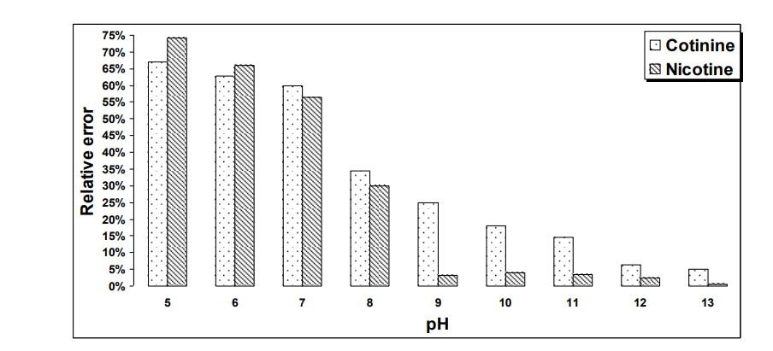
Figure 2.1: Example on inserting a Figure into the thesis text

2.2.1.2 Tables
Each table in a thesis must have a caption that tells concisely what it contains. The caption must be placed above a table and to be single-spaced. A demonstrative example on a table is given below.

Table 2.1: An example on a table that can be included within the thesis.
 |  | Calculated Results
Measure 1 | Test 1 | Variable x | Variable y | Variable z
 | Test 2 | xxxx | ttttyuyuu | ttttyuyuu
Measure 2 | Test 3 | ttttt | rrrrrr | rrrrrr
 | Test 4 | fffff | vvvvv | vvvvv

2.3 Literature Work
A literature review is a survey of scholarly sources on a specific topic. It provides an overview of current knowledge, allowing you to identify relevant theories, methods, and gaps in the existing research. Writing a literature review involves finding relevant publications (such as books and journal articles), critically analyzing them, and explaining what you found. There are five key steps:
- Search for relevant literature
- Evaluate sources
- Identify themes, debates and gaps
- Outline the structure
- Write your literature review
A good literature review doesn’t just summarize sources—it analyzes, synthesizes, and critically evaluates to give a clear picture of the state of knowledge on the subject. A literature review is a piece of discursive prose, not a list describing or summarizing one piece of literature after another. It’s usually a bad sign to see every paragraph beginning with the name of a researcher. Instead, organize the literature review into sections that present themes or identify trends, including relevant theory. You are not trying to list all the material published, but to synthesize and evaluate it according to the guiding concept of your thesis or research question.

Chapter Three: Thesis Case of Study

3.1 What is Thesis Case of Study
The case study analyses a specific existing problem needs to be solved. It should relate the theory to a practical situation; for example, apply the ideas and knowledge discussed in the coursework to the practical situation at hand in the case study.

3.2 Keys to Case of Study
A case study is a subcategory of research design which investigates problems and offers solutions. Case studies can range from academic research studies to corporate promotional tools trying to sell an idea—their scope is quite vast. Here, the following keys can be followed:
  - Outline the purpose of the case study.
  - Describe the field of research.
  - Outline the issues and findings of the case study without the specific details.
  - Identify the theory that will be used.
  - Note any assumptions made (you may not have all the information you'd like so some assumptions may be necessary e.g.: "It has been assumed that…", "Assuming that it takes half an hour to read one document…"). 1. Identify the problems.

Chapter Four: Thesis Methodology

4.1 What is the Thesis Methodology
The thesis methodology is a section of your research that provides your audience with an explanation of how you are set to carry out your research, where the data for your research will come from, the sorts of gathering techniques you will be using among other information.
It is expected that anyone reading your methodology will have just enough data needed to create similar research methods in obtaining future data, the thesis methodology section is primarily for providing explanations on why you have chosen to use specific data techniques in gathering data for your research.

4.2 Tips on Thesis Methodology
In your thesis, you will have to discuss the methods you used to do your research. The methodology chapter explains what you did and how you did it, allowing readers to evaluate the reliability and validity of the research. It should include:
- The type of research you did
- How you collected your data
- How you analyzed your data

Moreover, when writing a thesis methodology, you should not be bothered by having to list down all the methods you will be using as well as sources and fail to have a section that discusses how and why these methods were suitable to you. In this section, you must be sure to talk to your supervisor who should be giving you any other requirements that should be included in your thesis documentation. There are vital decisions that you will have to make when making a choice to create your thesis methodology.

Chapter Five: Results and Discussions

5.1 Introduction
When writing a thesis, the results and discussion sections can be both the most interesting as well as the most challenging sections to write. You may choose to write these sections separately, or combine them into one section. Writing the results and discussion as separate sections allows you to focus first on what results you obtained and set out clearly what happened in your experiments and/or investigations without worrying about their implications. This can focus your mind on what the results actually show and help you to sort them in your head. However, many people find it easier to combine the results with their implications as the two are closely connected.

5.2 Writing up Your results in a Thesis

5.2.1. Preliminaries
Once you’ve finished collecting and analyzing your data, you can begin writing up the results. This is where you report the main findings of your research. All relevant results should be reported concisely and objectively in a logical order. You may use tables and graphs to illustrate specific findings. Don’t include subjective interpretations of why you found these results or what they mean – your evaluation should be saved for the discussion.

5.2.2. Graphs, Tables, or Photographs
Observations are derived from the application of your methodology or method. These can be best presented using tables and graphs as objective representation of the measurements that you made. Numbers are more definite approximations of reality compared to just mere words. Words are more subjective and replete with misunderstanding. The following tips are valuable:
- Be consistent with your units of measurement. If you start off with kg, then use the same unit all throughout your paper.
- Be honest in presenting information even if the result is unexpected. Whether the result is positive or negative, present it. This is an objective move.
- You may also add photographs whenever needed but make sure these are relevant, not just whimsical addition to your paper or a means to flaunt your good photography skills; although it would be advantageous to show such skill coupled with relevance. Pictures can speak a thousand words.
- In general, give as much detail as possible in your presentation of the results. Read and reread your statements for clarity. Engage a competent friend or a colleague’s discerning eye for details.
- Your key results should be stated clearly at the beginning of each paragraph. It should serve as the topic sentence. Support that statement with more detail such as presenting the results of statistical analysis.

5.3 Writing up Your Discussion in a Thesis
It was noticed that miss this part. The results were presented as well as the analysis but no discussion is in sight. So, what comprises the discussion? Here’s what should be present in the discussion part:
5.3.1 Insightful Interpretation of Results
Insightful interpretation means well thought explanations. That means you will have to ponder deeply the results of your study and make a knowledgeable statement of your interpretation using the body of evidence at hand. This is where you cite evidences obtained by other authors. You either confirm or affirm other people’s work or refute using your own findings.
5.3.2 Generalizations
Be on guard in writing your generalizations. Make sure that the data you analyzed can be extrapolated or will allow you to predict somehow the behavior of one variable. If you have enough samples then you may make a generalization.
How enough is enough, you may ask. If your data has little variability as indicated by low variances, then it is possible that additional measurements will not change whatever trend you have.
You may guess but make it educated, meaning, you have done your homework. You have reviewed the literature and use it as a leverage for advancing your hypothesis or inference.
Does your finding support or refute what has been done so far? Does it support previously advanced hypotheses?
Remember that there is no such thing as a simple explanation of a complex phenomenon. Find one that is most aligned to your findings. It would be interesting to be in the controversial side as long as you have done your study systematically and bias is reduced to a minimum.

5.4 Summary
The summary is a key part of your thesis and part of what is evaluated by your thesis committee. Make sure to reserve sufficient time at the very end to write a very good summary. The summary should be about one page long and include your research question, describe the data you used, briefly describe the methodology applied and (very important) also summarize the results you found. Basically, the purpose of the summary is to give the reader an overview of the main points of your thesis. The summary should include the following points:
- What is the thesis about?
- What is the purpose of the thesis?
- What were the methods used to research the information?
- What are the results, conclusions, and recommendations that the thesis presents?

Chapter Six: Conclusion and Future Work

6.1 Conclusion
The conclusion is the very last part of your thesis. Its main purposes are to:
- Clearly state the answer to the main research question
- Summarize and reflect on the research
- Make recommendations for future work on the topic
- Show what new knowledge you have contributed

The conclusion should be concise and engaging. Aim to leave the reader with a clear understanding of the main discovery or argument that your research has advanced. Moreover, the conclusion contains similar elements to the discussion, and sometimes these two sections are combined (especially in shorter papers and journal articles). But in a thesis, it’s usual to include a final chapter that wraps up your research and gives the reader a final impression of your work. The conclusion chapter should be shorter and more general than the discussion. Instead of discussing specific results and interpreting the data in detail, here you make broad statements that sum up the most important insights of the research.
Note: The conclusion should not introduce new data, interpretations, or arguments.

Depending on the type of thesis, the conclusion should typically be around 5-7% of the overall word count. An empirical scientific study will often have a short conclusion that concisely states the main findings and recommendations, while a humanities thesis might require more space to conclude its analysis and tie all the chapters together in an overall argument.

6.2 Recommendations and Future Work
In this section, you finally have the opportunity to present and discuss the actions that future researchers should take as a result of your Project. A well-thought-out set of recommendations makes it more likely that the organization will take your recommendations seriously. Ideally you should be able to make a formal recommendation regarding the alternative that is best supported by the study. Present and discuss the kinds of additional research suggested by your Project. If the preferred alternative is implemented, what additional research might be needed?
In fact, many postgraduate students make recommendations that are too broad, too generic, or not directly related to the exact topic of their research. These recommendations are not wrong; they are simply not specific / relevant enough. Examiners like to see some more mundane recommendations that come specifically from the thesis / research work.

References
The references sections must follow one of two adopted referencing styles, namely:

- Harvard Style
- Vancouver Style

The easiest way to get this styling format is to go to Google Scholar and type the title of the reference (or relative keywords). Then, you will get something similar to what is shown in Figure 2 below. When clicking on the quotation-like sign (as indicated by the black arrow in Figure 2), you will get the refences styling page, similar to what is shown in Figure 3 below. Then, you can just copy and paste the required reference formatted according to one of the styles adopted by FGS in JUST (see the two styles under the free shape square).
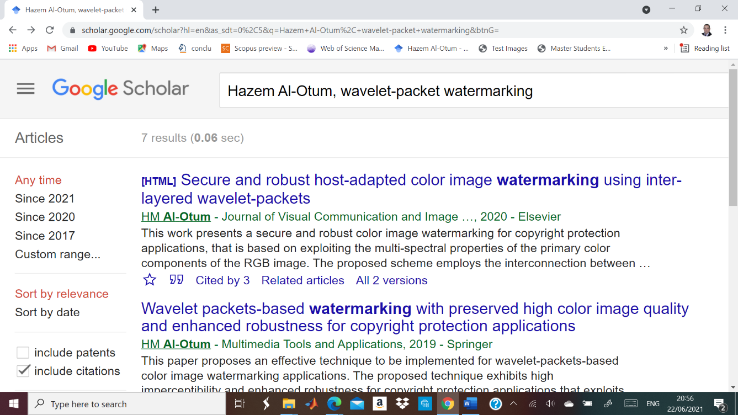

Figure 2: Results of searching Google Scholar for a specific reference
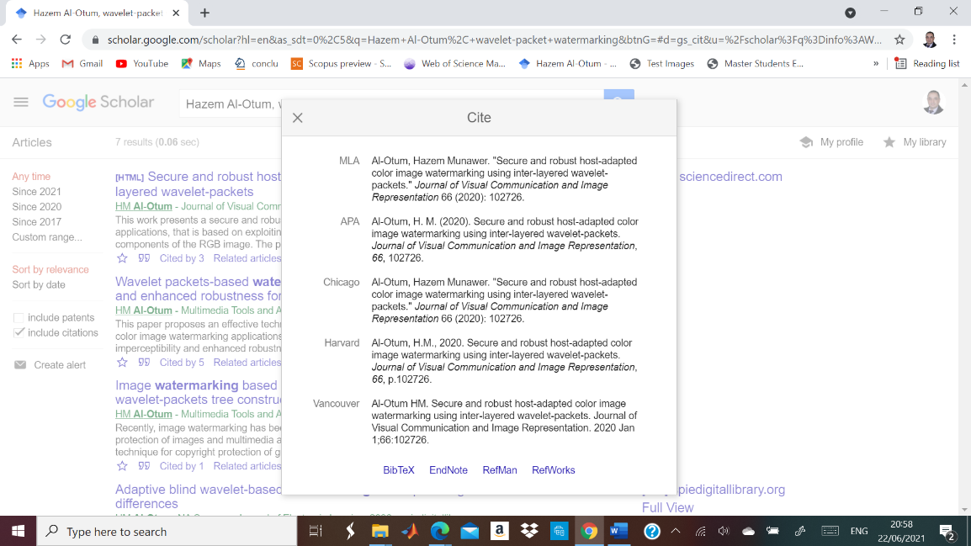

Figure 3: Results of clicking the cite sign in Google Scholar

Appendix A
An appendix is a section at the end of that contains supplementary information. An appendix may contain figures, tables, raw data, and other additional information that supports the arguments of your but do not belong in the main body.
When writing the main body of your thesis, it is important to keep it short and concise in order to convey your arguments effectively.
Given the amount of research you would have done; you will probably have a lot of additional information that you would like to share with your audience.
This is where appendices come in. Any information that doesn’t support your main arguments or isn’t directly relevant to the topic of your thesis should be placed in an appendix.
Note, however, that your main body must be detailed enough that it can be understood without your appendices. If a reader has to flip between pages to make sense of what they are reading, they are unlikely to understand it.
For this reason, appendices should only be used for supporting background material and not for any content that doesn’t fit into your word count, such as the second half of your literature review.

Appendix B
Note that, when required, the Appendix section can be divided into subsections as Appendix A, Appendix B, etc.

عنوان الرسالة

اعداد: اسم الطالب

الملخص

كتابة الملخص بحجم خط 12 و نوع Times new Roman

This Template has been prepared according to JUST Regulations and using the following websites that can be also valuable for extra readings:

- How To Write A Master's Thesis » Complete Guide (essayprowriter.com)
- Microsoft Word - ThesisGdlnsFinal1-08.doc (unk.edu)
- How to Write a Thesis Conclusion | Checklist and Examples (scribbr.com)
- How to write a fantastic PhD thesis conclusion - The PhD Knowledge Base (thephdproofreaders.com)
- BU Research Blog | Thoughts on writing recommendations for a research thesis | Bournemouth University
- How to Write a Thesis Conclusion and Recommendation Chapter? (uniresearchers.co.uk)

